NETWORKING TASK 01: UNDERSTANDING YOUR NETWORK ENVIRONMENT

Submitted By
Name: Meghana S
Internship: Networking Internship
Task: Networking Task 01 – Understanding Your Network Environment
Date: 06-06-2026

Objective
The objective of this task is to understand the basic components of a computer network and identify the network configuration of my system. This activity provides practical exposure to networking concepts and network diagnostic tools.

Part A: Network Information

System Network Details
Parameter | Value
Hostname (Device Name) | DESKTOP-S89TIEL
IPv4 Address | 192.168.50.131
MAC Address | xxxxxxxxxxx
Default Gateway | f4d8:e3ff:fe10:1df0%9 192.168.50.132
DNS Server | 192.168.50.132

Screenshot: ipconfig /all Output
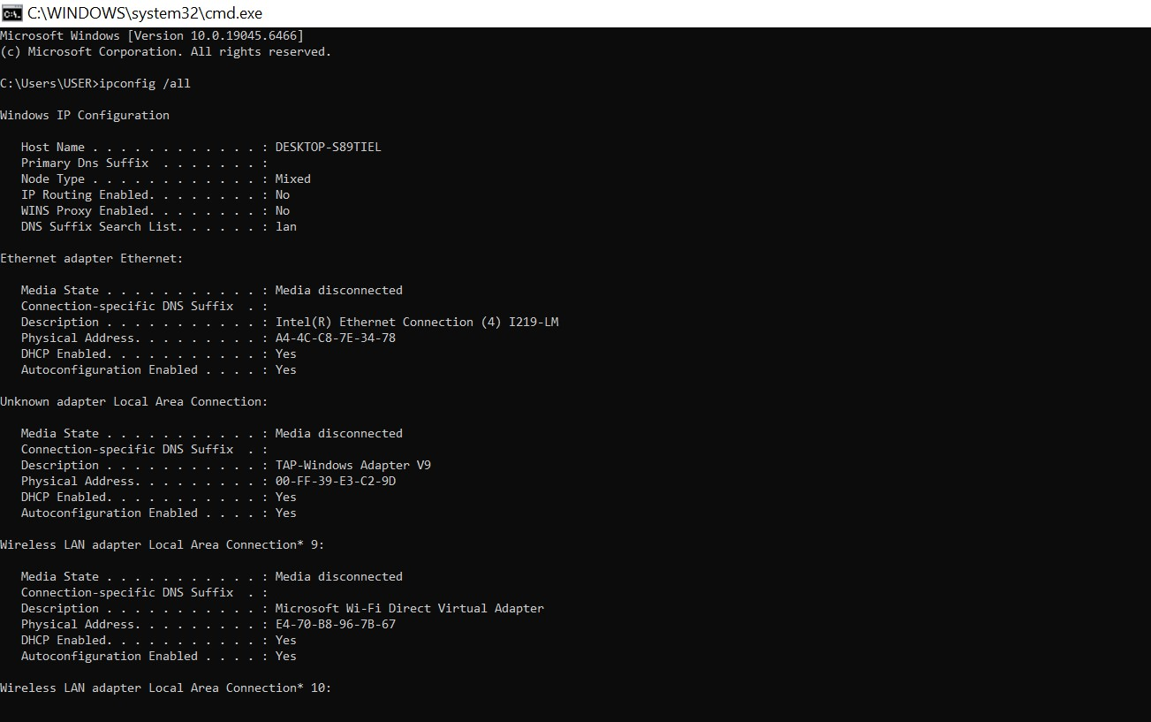

Part B: Basic Networking Concepts

What is an IP Address?
An IP Address (Internet Protocol Address) is a unique numerical identifier assigned to a device connected to a network. It enables devices to communicate and exchange data over the internet or a local network.

What is a MAC Address?
A MAC (Media Access Control) Address is a unique hardware address assigned to a network interface card by the manufacturer. It helps identify devices within a local network.

What is a Default Gateway?
A Default Gateway is a networking device, usually a router, that acts as an access point between a local network and external networks such as the internet.

What is DNS?
DNS (Domain Name System) is a service that translates human-readable website names such as www.google.com into IP addresses that computers can understand.

Difference Between Public IP and Private IP
Public IP Address | Private IP Address
Used on the Internet | Used within local networks
Assigned by ISP | Assigned by Router
Globally unique | Can be reused in different networks
Accessible from outside | Not directly accessible from outside

Part C: Basic Network Diagram

Network Structure
(Insert Network Diagram Here)
Example:
Internet
↓
Router / Wi-Fi
↓
My Device

Explanation
The device connects to the local router through Wi-Fi or Ethernet. The router acts as a gateway and provides access to the internet. All requests from the device pass through the router before reaching external servers.

Part D: Network Connectivity Test

Command 1: Ping Test
Command Used: ping google.com

Screenshot
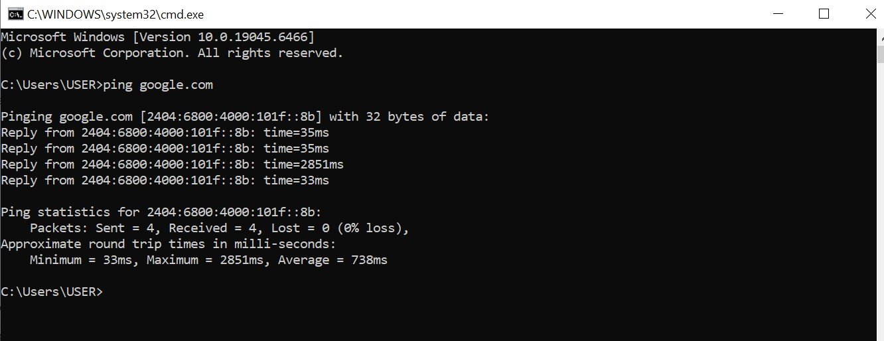

Observation
The ping command was executed successfully and replies were received from Google's server. This confirms that the device has an active internet connection and can communicate with external servers.

Answer
Was the ping successful?
Yes, the ping was successful and responses were received from Google's server.

Command 2: Traceroute Test
Command Used: tracert google.com

Screenshot
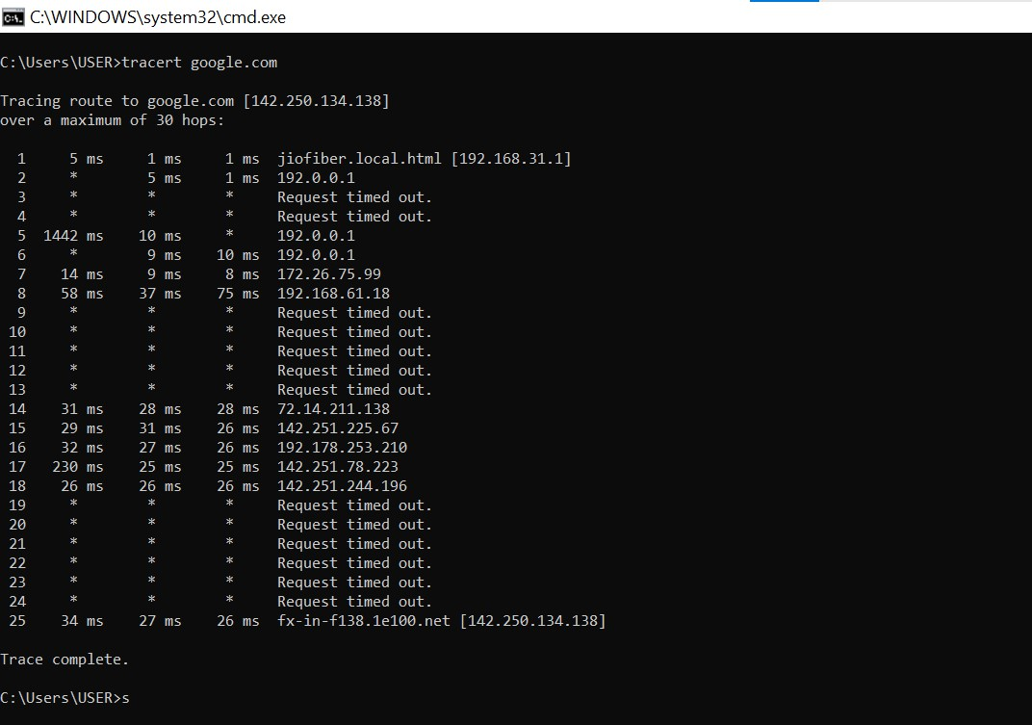

Observation
The traceroute command displayed the route taken by packets from the local device to Google's server through multiple intermediate network devices.

Answer
How many hops were shown?
Number of hops: 30 hops.

What is the purpose of traceroute?
Traceroute is a network diagnostic tool used to identify the path that data packets take from a source device to a destination server. It helps diagnose network delays and connectivity issues.

Findings

Router IP Address

Device IP Address

DNS Server

Conclusion
This task provided practical knowledge about networking fundamentals and system network configuration. Through the use of networking commands such as ipconfig, ping, and traceroute, I learned how devices communicate over a network, how IP addressing works, and how network connectivity can be tested and analyzed. The task improved my understanding of network infrastructure and basic troubleshooting techniques.

